**Assignment/Project Day 4**

**Submitted by –SHUBHAM SINGH**

**Linux Instance 01**

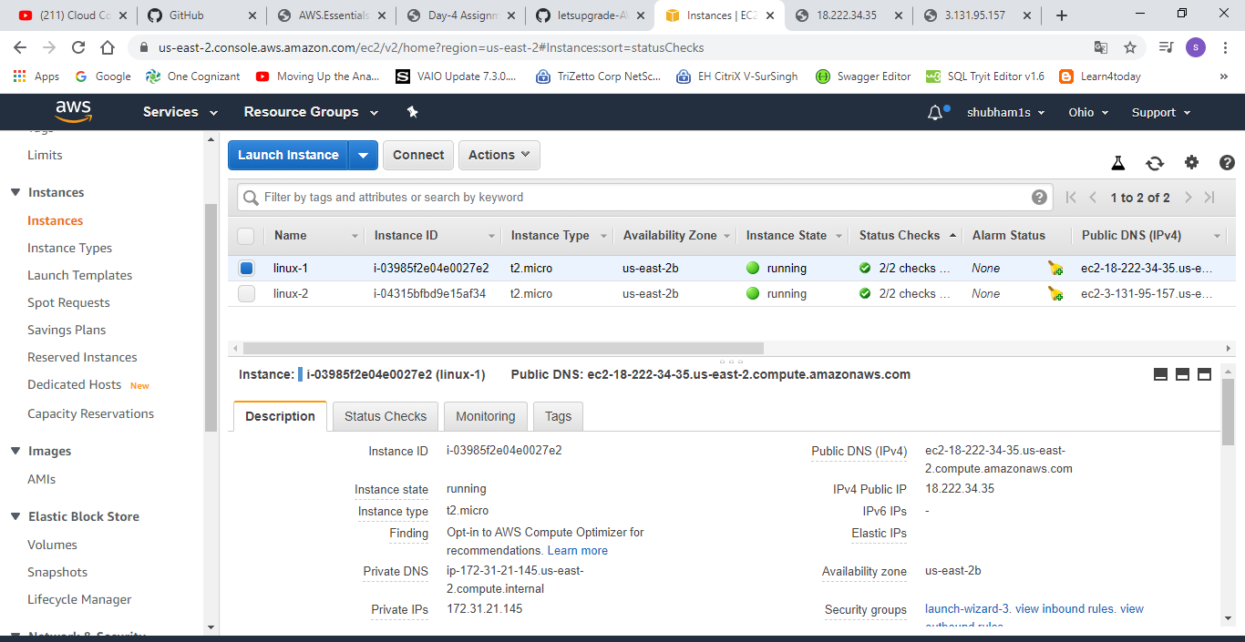

**Linux Instance 02**

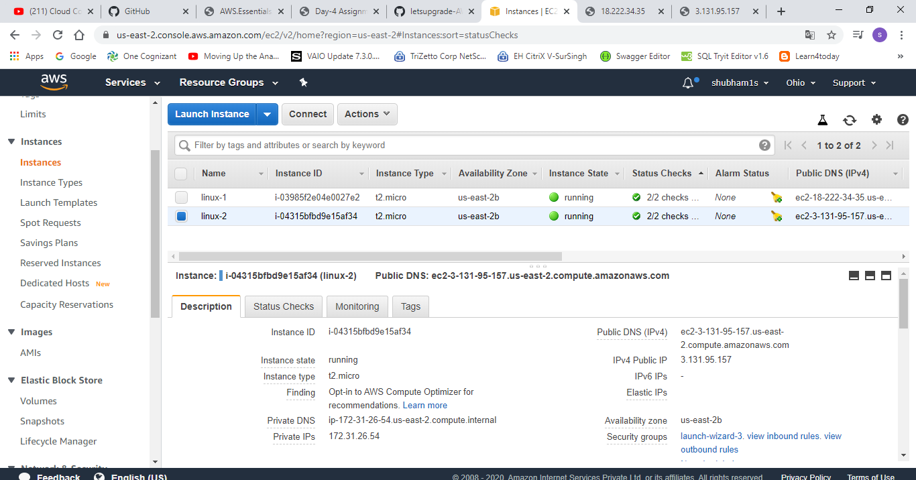

**Web hosting Linux Instance 01**

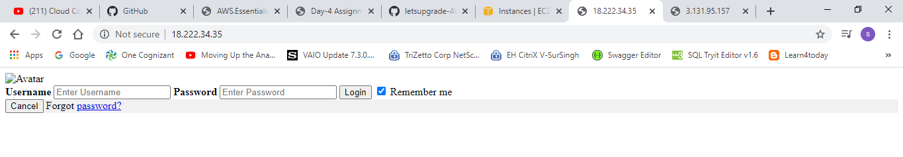

**Web hosting Linux Instance 02**

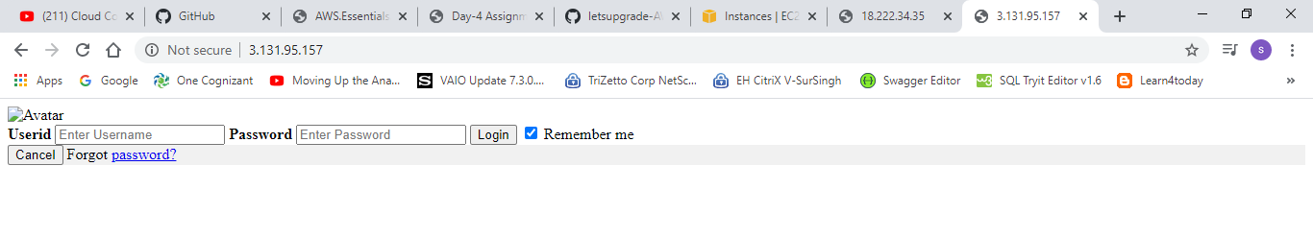

**Elastic Load Balancer (ELB)**

